Name

Mathematics Advanced Year 11
Logarithmic Functions

Book 1 |  | Version: 261021  Feedback:  https://MrDingMaths.com
Contents
Syllabus Content 2
Introduction to Logarithms 3
The Logarithm Laws 10
Solving Equations and Change of Base Law 20
Exponential Modelling 28
Logarithmic Scales 32
The Logarithmic Curve 37
Logarithmic Inequalities 45
The Natural Logarithm 50
Exponential Rate of Change Problems involving Logarithms 54

Syllabus Content
MAV-11-08 analyses graphs of exponential and logarithmic functions
Logarithmic functions
- Define the logarithm of a number $y$, where $y>0$, to any positive base $a$ as the index to which $a$ is raised to give $y$
- Use the notation $\log_{a}{y}$ for the logarithm of $y$ to the base $a$
- Define the natural logarithm $\ln{a}=\log_{e}{a}$
- Use digital tools to determine rational and irrational values of exponential and logarithmic expressions
- Explain that $y=a^{x}$ is equivalent to $x=\log_{a}{y}$ for $a>0$and $a≠1$, and use the equivalence to solve equations of the form $a^{x}=b$, for $a>0$
- Recognise and use the logarithmic properties: $\log_{a}{a^{x}}=x$ for all real $x$, $a^{\log_{a}{x}}=x$ where $x>0$
- Derive the laws of logarithms from the laws of indices $\log_{a}{m}+\log_{a}{n}=\log_{a}\left(mn\right)$, $\log_{a}{m}-\log_{a}{n}=\log_{a}\left(\frac{m}{n}\right)$ and $\log_{a}\left(m^{n}\right)=n\log_{a}{m}$
- Justify the logarithmic results $\log_{a}{a}=1$, $\log_{a}{1}=0$ and $\log_{a}\left(\frac{1}{x}\right)=-\log_{a}{x}$
- Apply the logarithmic laws and results to simplify expressions, solve equations and prove results, using digital tools where necessary
- Prove the change of base rule $\log_{a} x=\frac{\log_{b} x}{\log_{b} a}$and use it to solve problems
- Graph the logarithmic function $y=log_{a}x$ for $a>0$ and $a≠1$
- Use graphing applications to identify the graphs of $y=a^{x}$ and $y=\log_{a}{x}$ as reflections of each other in the line $y=x$, in cases where $a>1$ and $0<a<1$
MAV-12-02 models, analyses and solves practical problems involving functions and their transformations
Modelling with functions
- Recognise that logarithmic scales are useful to represent a variable that ranges over a large set of values and explain when a logarithmic scale is suitable
- Use logarithmic scales to model and solve problems involving decibels (dB) in acoustics, seismic scales for earthquakes, magnitudes of stars and the pH scale in chemistry

Introduction to Logarithms

- Review
- Recall powers of numbers.
$$x$$ | 0 | 1 | 2 | 3 | 4 | 5
$$2^{x}$$
$$3^{x}$$ |  |  |  |  |  | 243
$$4^{x}$$ |  |  |  |  | 256
$$5^{x}$$ |  | 5
$${10}^{x}$$ |  |  | 100

- Solve exponential equations.
- $2^{x}=16$ | - $3^{x}=81$ | - $7^{x}=343$
- $5^{x}=\sqrt{x}$ | - $9^{x}=3$ | - $4^{x}=\frac{1}{16}$

- Investigation Logarithms
- Roots find the base when you know the power.
$$x^{3}=8 \\ \sqrt[3]{}= \sqrt[3]{} \\ x=\sqrt[3]{8}$$

- Logarithms find the power when you know the base.
$$2^{x}=8 \\ \log_{2}{}=\log_{2}{} \\ x=\log_{2}{8}$$
Solve these equations using your knowledge of exponentiation and write the logarithm.

Exponential | $3^{x}=9$ | $3^{x}=27$ | $3^{x}=81$
Logarithm | $x=\log_{3}{9}=$ | $x=\log_{3}{27}=$ | $x=\log_{3}{81}=$

Exponential | $2^{x}=8$ | $2^{x}=16$ | $2^{x}=64$
Logarithm | $x=\log_{2}{8}=$ | $x=$

Exponential | $2^{x}=256$ | $4^{x}=256$ | ${16}^{x}=256$
Logarithm

Exponential | $5^{x}=25$ | $5^{x}=$ $\frac{1}{25}$ | $6^{x}=$ $\frac{1}{36}$
Logarithm

Logarithms are the inverse of exponentiation, they tell you the ………………, given a base number.

The log form of $8=2^{3}$ is The log form of $y=a^{x}$ is

$\log_{3}{27}$ is read as “log base three twenty-seven.” It means “the power of ……… that gives 27”

- Logarithms are the Inverse of Exponentiation
For $a>0, y>0:$
$$a^{x}=y \\ x=\log_{a}{y}$$

- Convert from index form to log form.
Write the following in logarithm form.
$$6^{2}=36 \\ 2=\log_{6}{36}$$ | $${10}^{-2}=\frac{1}{100} \\ -2=\log_{10}{\frac{1}{100}}$$ | $$9^{\frac{1}{2}}=3 \\ \frac{1}{2}=\log_{9}{3}$$
- $7^{2}=49$ | - $5^{0}=1$ | - ${10}^{-2}=0.01$
- ${16}^{\frac{1}{2}}=4$ | - ${10}^{4}=10 000$ | - ${\left(\frac{3}{4}\right)}^{2}=\frac{9}{16}$

- Convert from log form to index form.
Write the following in index form.
$$\log_{3}{9}=2 \\ 9=3^{2}$$ | $$\log_{8}{2}=\frac{1}{3}$$  $$2=8^{\frac{1}{3}}$$ | $$\log_{6}{\frac{1}{36}=-2}$$  $$\frac{1}{36}=6^{-2}$$
- $\log_{7}{49}=2$ | - $\log_{49}{7}=\frac{1}{2}$ | - $\log_{5}{\frac{1}{25}}=-2$
- $\log_{8}{16}=\frac{4}{3}$ | - $1=\log_{7}{7}$ | - $\log_{3}{5}=1.465$

Foundation
- Write in index form.
- $log₂ 16 = 4$  $$16 = 2⁴$$ | - $log₁₀ 100 = 2$  $$100 = 10²$$ | - $log₃ 27 = 3$  $$27 = 3³$$
- $log₂ (\frac{1}{4}) = -2$  $$\frac{1}{4}= 2^{-2}$$ | - $log₁₀ 0.1 = -1$  $$0.1 = {10}^{-1}$$ | - $\log_{3}\left(\frac{1}{9}\right) = -2$  $$\frac{1}{9}= 3^{-2}$$

- Write in log form.
- $2³ = 8$  $$3 = log_{2}8$$ | - $3⁴ = 81$  $$4 = log_{3} 81$$ | - $2⁵ = 32$  $$5 = log_{2} 32$$
- $4² = 16$  $$2 = log_{4} 16$$ | - ${10}^{-1}=\frac{1}{10}$  $$-1 = log_{10}\left(\frac{1}{10}\right)$$ | - $5^{-3}=\frac{1}{125}$  $$-3 = log_{5}\left(\frac{1}{125}\right)$$

- Write in log form.
- $3^{x}= y$  $$x = log_{3} y$$ | - $5^{x}= z$  $$x = log_{5} z$$ | - $x^{2}= y$  $$2 = log_{x} y$$
- $2^{b}= a$  $$b = log_{2} a$$ | - $b^{3}= d$  $$3 = log_{b} d$$ | - $y = 8^{x}$  $$log_{8}y=x$$
- $y = 6^{x}$  $$log_{6}y=x$$ | - $y = e^{x}$  $$log_{e}y=x$$ | - $y = a^{x}$  $$\log_{a}{y}=x$$

- Write in index form.
- $log_{3}5 = x$  $$5=3^{x}$$ | - $log_{4}7 = x$  $$7=4^{x}$$ | - $log_{3}a = b$  $$a=3^{b}$$
- $log_{x}y = 9$  $$y=x^{9}$$ | - $log_{a}b = y$  $$b=a^{y}$$ | - $y = log_{2}6$  $$2^{y}=6$$
- $y = log_{3}x$  $$3^{y}=x$$ | - $y = log_{10}9$  $${10}^{y}=9$$ | - $y=\log_{e}{4}$  $$e^{y}=4$$

Development
- Rewrite each equation in index form, then use your knowledge of powers to solve for $x$.
- $x = \log_{10}1000$  $$10ˣ = 1000, x = 3$$ | - $x = \log_{10}10$  $$10ˣ = 10, x = 1$$ | - $x = \log_{10}1$  $$10ˣ = 1, x = 0$$
- $x = \log_{10}\left(\frac{1}{100}\right)$  $$10ˣ =\frac{1}{100}, x = -2$$ | - $x = \log_{3}9$  $$3ˣ = 9, x = 2$$ | - $x = \log_{5}125$  $$5ˣ = 125, x = 3$$
- $x = \log_{2}64$  $$2ˣ = 64, x = 6$$ | - $x = \log_{4}64$  $$4ˣ = 64, x = 3$$ | - $x = \log_{8}64$  $$8ˣ = 64, x = 2$$
- $x = \log_{7}\left(\frac{1}{7}\right)$  $$7ˣ =\frac{1}{7}, x = -1$$ | - $x = \log_{12}\left(\frac{1}{12}\right)$  $$12ˣ =\frac{1}{12}, x = -1$$ | - $x = \log_{11}\left(\frac{1}{121}\right)$  $$11ˣ =\frac{1}{121}, x = -2$$
- $x = \log_{6}\left(\frac{1}{36}\right)$  $$6ˣ =\frac{1}{36}, x = -2$$ | - $x = \log_{4}\left(\frac{1}{64}\right)$  $$4ˣ =\frac{1}{64}, x = -3$$ | - $x = \log_{8}\left(\frac{1}{64}\right)$  $$8ˣ =\frac{1}{64}, x = -2$$

- Solve for $x$ by first rewriting index form, or otherwise.
- $\log_{2}64 = x$  $$6$$ | - $\log_{10}1000 = x$  $$3$$ | - $\log_{2}x = 4$  $$16$$
- $\log_{3}x = 4$  $$81$$ | - $\log_{10}x = 3$  $$1000$$ | - $\log_{3}x = -2$  $$\frac{1}{9}$$
- $\log_{4}x = -1$  $$\frac{1}{4}$$ | - $\log_{7}x = -3$  $$\frac{1}{343}$$ | - $\log_{x}27 = 3$  $$3$$
- $\log_{x}32 = 5$  $$2$$ | - $\log_{x}64 = 3$  $$4$$ | - $\log_{x}81 = 4$  $$3$$

Mastery
- Solve each equation for $x$
- $x = \log_{7}\sqrt{7}$  $$7^{x}= \sqrt{7}, x =\frac{1}{2}$$ | - $x = \log_{11}\sqrt{11}$  $${11}^{x}= \sqrt{11}, x =\frac{1}{2}$$ | - $\log_{9}x =\frac{1}{2}$  $$x = 9^{\frac{1}{2}}= 3$$
- $\log_{144}x = \left(\frac{1}{2}\right)$  $$x = {144}^{\frac{1}{2}}= 12$$ | - $\log_{x}3 = \left(\frac{1}{2}\right)$  $$x^{\frac{1}{2}}= 3, x = 9$$ | - $\log_{x}13 =\frac{1}{2}$  $$x^{\frac{1}{2}}= 13, x = 169$$
- $x = \log_{6}\sqrt[3]{6}$  $$6^{x}= \sqrt[3]{6}, x =\frac{1}{3}$$ | - $x = \log_{9}3$  $$9^{x}= 3, x =\frac{1}{2}$$ | - $\log_{64}x =\frac{1}{3}$  $$x = {64}^{\frac{1}{3}}= 4$$
- $\log_{16}x =\frac{1}{4}$  $$x = {16}^{\frac{1}{4}}= 2$$ | - $\log_{x}2 =\frac{1}{3}$  $$x^{\frac{1}{3}}= 2, x = 8$$ | - $\log_{x}2 =\frac{1}{6}$  $$x^{\frac{1}{6}}= 2, x = 64$$
- $x = \log_{8}2$  $$8^{x}= 2, x =\frac{1}{3}$$ | - $x = \log_{125}5$  $${125}^{x}= 5, x =\frac{1}{3}$$ | - $\log_{7}x =\frac{1}{2}$  $$x =7^{\frac{1}{2}}= \sqrt{7}$$
- $\log_{7}x = -\frac{1}{2}$  $$x =7^{-\frac{1}{2}}=\frac{1}{\sqrt{7}}$$ | - $\log_{x}\left(\frac{1}{7}\right)= -\frac{1}{2}$  $$x^{-\frac{1}{2}}=\frac{1}{7}, x = 49$$ | - $\log_{x}\left(\frac{1}{20}\right)= -\frac{1}{2}$  $$x^{-\frac{1}{2}}=\frac{1}{20}, x = 400$$
- $x = \log_{4}\left(\frac{1}{2}\right)$  $$4^{x}=\frac{1}{2}, x = -\frac{1}{2}$$ | - $x= \log_{27}\left(\frac{1}{3}\right)$  $${27}^{x}=\frac{1}{3}, x = -\frac{1}{3}$$ | - $\log_{121}x = -\frac{1}{2}$  $$x = {121}^{-\frac{1}{2}}=\frac{1}{11}$$
- $\log_{81}x = -\left(\frac{1}{4}\right)$  $$x = {81}^{-\frac{1}{4}}=\frac{1}{3}$$ | - $\log_{x}\left(\frac{1}{2}\right)= -\frac{1}{4}$  $$x^{-\frac{1}{4}}=\frac{1}{2}, x = 16$$ | - $\log_{x}2 = -\frac{1}{4}$  $$x^{-\frac{1}{4}}= 2, x =\frac{1}{16}$$

- A single bacterium cell divides into two every minute.
  - Complete this cell population table.
Time (min) | 0 | 1 | 2 | 3 | 4
Population | 1 | 2 | 4 | 8 | 16

  - Write an equation for the population, $P$, after $t$ minutes.
$$P=2^{t}$$
  - Use your rule to find the population after 8 minutes.
$$P=2^{8}=256$$
  - Use trial and error to find the time (correct to the nearest minute) for the population to rise to 10000.
13 minutes
  - Write the exact answer to part d as a logarithm.
$$2^{t}=1000$$
$$t=\log_{2}{1000}$$

- HSC Sample Question Band 4
If $y=\log_{a}\left(7x-b\right)+3$, then $x$ is equal to:
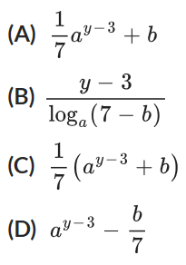

$$y-3=\log_{a}\left(7x-b\right)$$
$$a^{y-3}=7x-b$$
$$7x=a^{y-3}+b$$
$$x=\frac{1}{7}\left(a^{y-3}+b\right)$$
C

The Logarithm Laws

- Review
- Simplify expressions using index laws.
- ${\left(\sqrt{3}\right)}^{2}$ | - $\sqrt{3^{2}}$ | - $3^{x}×3^{y}$ | - $\frac{3^{x}}{3^{y}}$
- ${\left(3^{x}\right)}^{y}$ | - $3^{0}$ | - $3^{-1}$ | - $3^{-x}$

- The Inverse Relationship
Logarithms and exponentiating are inverse operations.
Taking the logarithm will “undo” exponentiation.
$\log_{a}\left(a^{x}\right)=x$ for all real $x$
$a^{\log_{a}{x}}=x$ for all real $x>0$

- Identify inverse relationship between logarithms and exponentiation.
Simplify
$$\log_{7}{7^{12}}=12$$ | $${\log_{11}{11}}^{15}=15$$ | $$3^{\log_{3}{5}}=5$$
- $\log_{10}{{10}^{3}}$ | - $\log_{12}{{12}^{1.3}}$ | - $\log_{a}{a^{14}}$
- $6^{\log_{6}\left(-2\right)}$ | - $e^{\log_{e}{97}}$ | - $3^{\log_{5}{3}}$

- The Log Laws
The logarithm laws work like the index laws
Inverse Relationship | ${\log_{a}{a}}^{x}=a^{\log_{a}{x}}=x$
Log Law of Multiplication | $$\log_{a}\left(xy\right)=\log_{a}{x}+\log_{a}{y}$$
Log Law of Division | $$\log_{a}\left(\frac{x}{y}\right)=\log_{a}{x}-\log_{a}{y}$$
Log Law of Indices | $$\log_{a}{(x^{n})}=n\log_{a}{x}$$

- Simplify expressions using the log laws.
- $\log_{6}{2}+\log_{6}{4}$ | - $\log_{2}{3}+\log_{2}{7}$ | - $\log_{3}{2}+\log_{5}{2}$
- $\log_{6}{2}-\log_{6}{4}$ | - $\log_{2}{3}-\log_{2}{7}$ | - $\log_{3}{2}-\log_{5}{2}$
- $\log_{6}\left(2^{5}\right)$ | - $\log_{2}\left(7^{-3}\right)$ | - $\log_{3}\left(3^{5}\right)$
- $\log_{9}{18}-\log_{9}{3}$ | - $\log_{7}{2}+\log_{7}{3}$ | - $\log_{a}{22}-\log_{a}{11}$
- $\log_{a}\left(2^{3}\right)$ | - $\log_{3}{15+\log_{3}{3}}$ | - $\log_{4}\left(5^{2}\right)$

- Evaluating Logarithms using Log Laws
$$\log_{a}{(1)}=0$$ | because $1=a^{0}$
$$\log_{a}{(a)}=1$$ | because $a=a^{1}$
$$\log_{a}{(\sqrt{a}})=\frac{1}{2}$$ | because $\sqrt{a}=a^{\frac{1}{2}}$
$$\log_{a}{(\sqrt{x}})=\frac{1}{2} \log_{a}\left(x\right)$$ | because $\log_{a}\left(\sqrt{x}\right)={\log_{a}{(x}}^{\frac{1}{2}})=\frac{1}{2}\log_{a}{x}$
$$\log_{a}{\frac{1}{a}}=-1$$ | because $\frac{1}{a}=a^{-1}$
$$\log_{a}\left(\frac{1}{x}\right)=-\log_{a}{x}$$ | because $\log_{a}\left(\frac{1}{x}\right)={\log_{a}{(x}}^{-1})=-\log_{a}{x}$

- Evaluate expressions using the log laws.
- $\log_{3}{1}$ | - $\log_{7}{7}$ | - $\log_{3}{\sqrt{3}}$
- $\log_{4}{\frac{1}{4}}$ | - $\log_{5}{\sqrt{7}}$ | - $\log_{6}{\sqrt{6}}$
- $\log_{12}{\frac{1}{12}}$ | - $\log_{100}{1}$ | - $\log_{5}{\frac{1}{6}}$

- Example Evaluate expressions using log laws.
$\log_{2}{6}-\log_{2}{3}$  $$=\log_{2}{2}$$  $$=1$$ | $$\log_{6}{\frac{1}{36}}$$  $$=\log_{6}{{36}^{-1}}$$  $$=\log_{6}{6^{-2}}$$  $$=-2\log_{6}{6}$$  $=-2$

- Practice
- $\log_{6}{2}+\log_{6}{3}$  1 | - $\log_{3}{15}-\log_{3}{5}$  1
- $\log_{2}{16}$  4 | - $\log_{4}{\frac{1}{64}}$  –3
- $\log_{5}{25}-\log_{5}{\sqrt{5}}$  1.5 | - $\frac{1}{2}\log_{2}{4}+2\log_{2}{8}$  7

Foundation
- State the missing numbers.
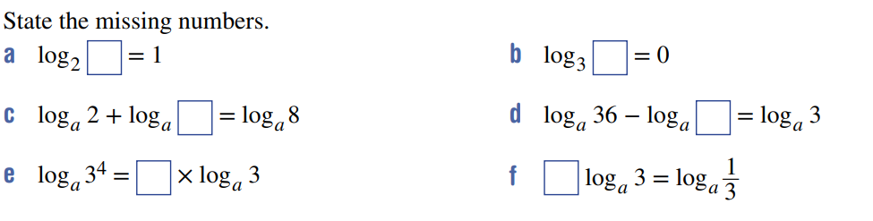  $$2$$ | $$1$$
$$4$$ | $$12$$
$$4$$ | $$-1$$

- Simplify using an appropriate log law.
- $log_{a}7 + log_{a}4$  $$\log_{a}28$$ | - $4 log_{a}2$  $$\log_{a}16$$ | - $2 log_{a}3$  $$\log_{a}9$$
- $log_{b}7 - log_{b}5$  $$log_{b}\left(\frac{7}{5}\right)$$ | - $log_{a}5 + log_{a}3$  $$\log_{a}15$$ | - $log_{b}15 + log_{b}1$  $$\log_{b}15$$
- $log_{a}10 - log_{a}5$  $$\log_{a}2$$ | - $3 log_{a}3$  $$\log_{a}27$$ | - $log_{b}28 - log_{b}14$  $$\log_{b}2$$
- $2 log_{a}5$  $$\log_{a}25$$ | - $log_{b}1 + log_{b}17$  $$\log_{b}17$$ | - $5 log_{a}2$  $$\log_{a}32$$
- $log_{a}3 + log_{a}2$  $$\log_{a}6$$ | - $log_{a}100 - log_{a}10$  $$\log_{a}10$$ | - $log_{b}6 + log_{b}3$  $$\log_{b}18$$
- $3 log_{a}10$  $$log_a 1000$$ | - $log_{a}36 - log_{a}12$  $$\log_{a}3$$ | - $log_{b}3 - log_{b}2$  $$\log_{b}\left(\frac{3}{2}\right)$$

- Evaluate:
- $\log_{3}1$  $$0$$ | - $\log_{7}1$  $$0$$ | - $\log_{x}1$  $$0$$ | - $\log_{4}4$  $$1$$
- $\log_{18}18$  $$1$$ | - $\log_{a}a$  $$1$$ | - $5 \log_{2}1$  $$0$$ | - $3 \log_{4}4$  $$3$$
- $\frac{1}{3}\log_{7}7$  $$\frac{1}{3}$$ | - $\frac{2}{3}\log_{10}10$  $$\frac{2}{3}$$ | - $\log_{15}{225}$  $$2$$ | - $\log_{3}{243}$  $$5$$

Development
- Evaluate the following expressions. The answers are whole numbers.
- $\log_{6}9 + \log_{6}4$  $$2$$ | - $\log_{5}75 - \log_{5}3$  $$2$$ | - $\log_{15}3 + \log_{15}5$  $$1$$
- $\log_{12}72 + \log_{12}2$  $$2$$ | - $\log_{10}50 + \log_{10}20$  $$3$$ | - $\log_{3}15 - \log_{3}5$  $$1$$
- $\log_{2}24 - \log_{2}3$  $$3$$ | - $\log_{3}810 - \log_{3}10$  $$4$$ | - $\log_{2}12+ \log_{2}6 - \log_{2}9$  $$3$$
- $\log_{30}2+\log_{30}3+\log_{30}5$  $$1$$ | - $\log_{12}9+\log_{12}8+\log_{12}2$  $$2$$ | - $\log_{2}12+\log_{2}6-\log_{2}72$  $$0$$
- $\log_{5}2 - \log_{5}50$  $$-2$$ | - $\log_{2}6 - \log_{2}48$  $$-3$$ | - $\log_{3}8- \log_{3}6 - \log_{3}12$  $$-2$$
- $\log_{5}12-\log_{5}20-\log_{5}15$  $$-2$$ | - $\log_{6}\left(\frac{1}{3}\right)- \log_{6}12$  $$-2$$ | - $\log_{7}\left(\frac{1}{9}\right)+ \log_{7}63$  $$1$$

- Write each expression in terms of $\log_{a}{2}$
- $\log_{a}8$  $$3\log_{a}{2}$$ | - $\log_{a}16$  $$4\log_{a}{2}$$ | - $\log_{a}64$  $$6\log_{a}{2}$$ | - $\log_{a}\left(\frac{1}{2}\right)$  $$-\log_{a}{2}$$
- $\log_{a}\left(\frac{1}{8}\right)$  $$-3\log_{a}{2}$$ | - $\log_{a}\left(\frac{1}{32}\right)$  $$-5\log_{a}{2}$$ | - $\log_{a}\sqrt{2}$  $$\frac{1}{2}\log_{a}{2}$$ | - $\log_{a}\left(\frac{1}{\sqrt{2}}\right)$  $$-\frac{1}{2}\log_{a}{2}$$

- Given that $log_{2}3 ≈ 1.58$ and $log_{2}5 ≈ 2.32$, use the log laws to find approximations for
- $\log_{2}15$  $$3.90$$ | - $\log_{2}9$  $$3.16$$ | - $\log_{2}10$  $$3.32$$ | - $\log_{2}50$  $$5.64$$
- $\log_{2}\left(\frac{3}{2}\right)$  $$0.58$$ | - $\log_{2}\left(\frac{3}{5}\right)$  $$-0.74$$ | - $\log_{2}\left(\frac{2}{3}\right)$  $$-0.58$$ | - $\log_{2}75$  $$6.22$$
- Simplify:
- $log_{10}{10}^{3}$  $$3$$ | - $log_{7}7^{5}$  $$5$$ | - $log_{12}{12}^{1.3}$  $$1.3$$ | - $log_{8}8^{n}$  $$n$$

- Simplify:
- ${10}^{\log_{10}100}$  $$100$$ | - $3^{\log_{3}7}$  $$7$$ | - $4^{\log_{4}36}$  $$3.6$$ | - $6^{\log_{6}y}$  $$y$$

- Evaluate:
- $\log_{2}\left(\frac{1}{4}\right)$  $$-2$$ | - $\log_{3}\left(\frac{1}{27}\right)$  $$-3$$ | - $\log_{4}\left(\frac{1}{64}\right)$  $$-3$$
- $\log_{5}\left(\frac{1}{5}\right)$  $$-1$$ | - $\log_{10}\left(\frac{1}{100}\right)$  $$-2$$ | - $\log_{10}\left(\frac{1}{100000}\right)$  $$-5$$
- $\log_{2}10 - \log_{2}5$  $$1$$ | - $\log_{3}30 - \log_{3}10$  $$1$$ | - $\log_{4}128 - \log_{4}2$  $$3$$
- $\log_{4}8 + \log_{4}2$  $$2$$ | - $\log_{8}16 + \log_{8}4$  $$2$$ | - $\log_{10}50 + \log_{10}2$  $$2$$

- Simplify to a single logarithm.
- $2 \log_{3}2 + \log_{3}5$  $$\log_{3}{20}$$ | - $4 \log_{10}2 + \log_{10}3$  $$\log_{10}{48}$$
- $3 \log_{10}2 - \log_{10}4$  $$\log_{10}{2}$$ | - $5 \log_{7}2 - \log_{7}16$  $$\log_{7}{2}$$
- $\frac{1}{2}\log_{3}4 + 2 \log_{3}2$  $$\log_{3}{8}$$ | - $\log_{5}3 -\frac{1}{2}\log_{5}9$  $$0$$
- $\frac{1}{3}\log_{2}27 -\frac{1}{3}\log_{2}64$  $$\log_{2}{\frac{3}{4}}$$ | - $\frac{1}{4}\log_{5}16 +\frac{1}{5}\log_{5}243$  $$\log_{5}{6}$$
- Simplify:
- $log_{2}\sqrt{8}$  $$=\log_{2}{8^{\frac{1}{2}}}$$  $$=\log_{2}{2^{\frac{3}{2}}}$$  $=$  $$\frac{3}{2}$$ | - $log_{2} \sqrt[3]{32}$  $$\frac{5}{2}$$ | - $log_{2} \sqrt[4]{16}$  $$\frac{4}{3}$$
- $log_{10}\sqrt{1000}$  $$\frac{3}{2}$$ | - $log_{7} \sqrt[3]{7}$  $$\frac{1}{3}$$ | - $log_{5} \sqrt[5]{625}$  $$\frac{4}{5}$$

- Simplify:
- $\log_{a}{a^{2}}$  $$2$$ | - $5\log_{a}{a^{3}}$  $$15$$ | - $\log_{a}{\frac{1}{a}}$  $$-1$$ | - $12\log_{a}{\sqrt{a}}$  $$6$$

- Write in terms of $\log_{a}{x}$
- $\log_{a}{x^{3}}$  $$3\log_{a}{x}$$ | - $\log_{a}{\frac{1}{x}}$  $$-\log_{a}{x}$$ | - $\log_{a}{\sqrt{x}}$  $$\frac{1}{2}\log_{a}{x}$$ | - $\log_{a}{\frac{1}{x^{2}}}$  $$-2\log_{a}{x}$$
- $\log_{a}{x^{3}}-\log_{a}{x^{5}}$  $$-2\log_{a}{x}$$ | - $\log_{a}{x^{4}}+\log_{a}{\frac{1}{x^{2}}}$  $$2\log_{a}{x}$$ | - $2\log_{a}{a^{4}}-\log_{a}{x^{8}}$  $$8-8\log_{a}{x}$$ | - $\log_{a}{\frac{1}{\sqrt{x}}}+3\log_{a}{\sqrt{x}}$  $$-\frac{1}{2}\log_{a}{x}$$

- If $x=\log_{a}{2}, y=\log_{a}{3}$ and $z=\log_{a}{5}$, write in terms of $x, y, z$:
- $\log_{a}{64}$  $$6x$$ | - $\log_{a}{\frac{1}{30}}$  $$-x-y-z$$ | - $\log_{a}{27}a^{5}$  $$3y+5$$ | - $\log_{a}{\frac{100}{a}}$  $$2x+2z-1$$
- $\log_{a}{1.5}$  $$y-x$$ | - $\log_{a}{\frac{18}{25a}}$  $$x+2y-2z-1$$ | - $\log_{a}{0.04}$  $$-2z$$ | - $\log_{a}{\frac{8}{15a^{2}}}$  $$3x-y-z-2$$

- Give exact values of:
- $\log_{25}{45}-\log_{25}{9}$  $$\frac{1}{2}$$ | - $\log_{81}{12}-\log_{81}{36}$  $$-\frac{1}{4}$$
- $\log_{8}{3}-\log_{8}{96}$  $$-\frac{5}{3}$$ | - $\log_{\frac{1}{32}}{5}-\log_{\frac{1}{32}}{10}$  $$\frac{1}{5}$$

- Simplify:
- $5^{-\log_{5}{2}}$  $$\frac{1}{2}$$ | - ${12}^{2\log_{12}{7}}$  $$49$$ | - $2^{\log_{2}{3}+\log_{2}{5}}$  $$15$$ | - $a^{n\log_{a}{x}}$  $$x^{n}$$
- $7^{-\log_{7}{x}}$  $$\frac{1}{x}$$ | - $5^{x+\log_{5}{x}}$  $$x×5^{x}$$ | - $2^{x\log_{2}{x}}$  $$x^{x}$$ | - $3^{\frac{\log_{3}{x}}{x}}$  $$x^{\frac{1}{x}}$$

- Rewrite in index form by making both sides a single logarithm then exponentiating both sides.
- $\log_{a}\left(x+y\right)=\log_{a}{c}+\log_{a}{d}$  $$x+y=cd$$ | - $\log_{10}{x}=3+\log_{10}{y}$  $$x=1000y$$
- $\log_{3}{x}=4\log_{3}{y}$  $$x=y^{4}$$ | - $2\log_{2}{x}+3\log_{2}{y}-4\log_{2}{z}=0$  $$x^{2}y^{3}=z^{4}$$
- $x\log_{a}{2}=\log_{a}{y}$  $$2^{x}=y$$ | - $\log_{a}{x}-\log_{a}{y}=n\log_{a}{z}$  $$x=yz^{n}$$
- $\frac{1}{2}\log_{2}{x}=\frac{1}{3}\log_{2}{y}-1$  $$64x^{3}=y^{2}$$ | - $2\log_{3}\left(2x+1\right)=3\log_{3}\left(2y-1\right)$  $${\left(2x+1\right)}^{2}={\left(2y-1\right)}^{3}$$

- HSC Sample Question Band 4
Solve ${100}^{x-2}={1000}^{x}$

$${\left({10}^{2}\right)}^{x-2}= {\left({10}^{3}\right)}^{x}$$
$${10}^{2\left(x-2\right)}= {10}^{3x}$$
$$2\left(x-2\right)= 3x$$
$$2x-4 = 3x$$
$$x = -4$$
- HSC Sample Question Band 4
Solve $2^{3x-3}=8^{2-x}$
$$2^{3x-3} = {\left(2^{3}\right)}^{2-x}$$
$$2^{3x-3} = 2^{3\left(2-x\right)}$$
$$3x-3 = 6-3x$$
$$6x = 9$$
$$x =\frac{3}{2}$$

- 2017 HSC Band 4
Solve $2\log_{3}{(5)}-\log_{3}{(2)}+\log_{3}{(x)}=2$
$$log_{3}\left(\frac{25}{2}\right) + log_{3}(x) = 2$$
$$log_{3}\left(\frac{25x}{2}\right) = 2$$
$$\frac{25x}{2}= 3^{2}$$
$$25x = 18$$
$$x =\frac{18}{25}$$

- HSC Sample Question Band 4
Solve $\log_{2}{(6-x)}-\log_{2}\left(4-x\right)=2$, when $x<4$
$$log_{2}\left(\frac{6-x}{4-x}\right) = 2$$
$$\frac{6-x}{4-x} = 4$$
$$6-x = 4(4-x)$$
$$6-x = 16-4x$$
$$3x = 10$$
$$x =\frac{10}{3}$$

Solving Equations and Change of Base Law

- Change of Base Law
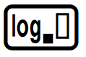
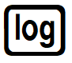
Calculators with the general log button can evaluate any logarithm. E.g. $\log_{2}{8}=3$.
Calculators with only the button can only evaluate log base 10
The 10 is hidden as most engineering applications use base 10: $∴\log{x}=\log_{10}{x}$

To evaluate logarithms on a basic calculator, we use the change of base law:

$$\log_{a}{b}=\frac{\log_{c}{b}}{\log_{c}{a}}$$

This lets you convert any logarithm to a base your calculator can handle (usually base 10).
- Many questions involving simplifying logarithms requires the change of base law.

- Rewrite logarithms using the change of base law.
$$\log_{2}{8}=\frac{\log_{10}{8}}{\log_{10}{2}}$$ | $$\log_{2}{8}=\frac{\log_{17}{8}}{\log_{17}{2}}$$ | $$\log_{5}{9}=\frac{\log_{17}{9}}{\log_{17}{5}}$$
Rewrite these logarithms with the required base using the change of base law.
$$\log_{3}{81}=\frac{\log_{10}{}}{\log_{10}{}}$$ | $$\log_{3}{81}=\frac{\log_{5}{}}{\log_{5}{}}$$ | $$\log_{7}{22}=\frac{\log_{e}{}}{\log_{e}{}}$$
- $\log_{6}{36}$, base $10$ | - $\log_{8}{21}$, base 15 | - $\log_{2}{5}$, base $a$

- Solving Equations of the form $a^{x}=b$ using Logarithms
1. Rewrite to make $x$ the subject using the rule:
$$a^{x}=b \\ x=\log_{a}{b}$$
2. Evaluate directly using or using the change of base law and

- Example Solve equations of the form $a^{x}=b$ using logarithms.
Solve $2^{x}=7$ to 3 d.p.
Method 1 using calculator with  $$2^{x}=7 \\ x=\log_{2}{7} \\ x=\frac{\log_{10}{7}}{\log_{10}{2}} \\ =2.807$$ | Method 2 using calculator with  $$2^{x}=7 \\ x=\log_{2}{7} \\ =2.807$$

- Practice
Solve to 3 d.p.
- $3^{x}=15$  $$2.465$$ | - $9^{x}=3$  $$x=0.500$$
- $3={27}^{x}$  $$0.333$$ | - $4^{x}=-2$  No solution
- $50×{1.1}^{x}=100$  $$7.273$$ | - $4^{x+1}=$ $\frac{1}{8\sqrt{2}}$  $$-2.750$$

Foundation
- Solve the following and round to three decimal places where necessary.
- $2^{x}= 6$  $$2.585$$ | - $3^{x}= 8$  $$1.893$$ | - $5^{x}= 7$  $$1.209$$
- ${11}^{x}= 15$  $$1.129$$ | - ${1.8}^{x}= 2.5$  $$1.559$$ | - ${0.9}^{x}= 0.5$  $$6.579$$
- $10 × 2^{x}= 100$  $$3.322$$ | - $7 × 3^{x}= 28$  $$1.262$$ | - $130 × 7^{x}= 260$  $$0.356$$
- $4 × {1.5}^{x}= 20$  $$3.969$$ | - $100 × {0.8}^{x}= 50$  $$3.106$$ | - $30 × {0.7}^{x}= 20$  $$1.137$$

- Solve these equations. Answer to 3 d.p. where appropriate.
- $5^{x}=125$  $$3$$ | - $4^{x}=512$  $$4.5$$ | - $3^{x}=13$  $$2.335$$
- $5^{x}=625$  $$4$$ | - $2^{x}=512$  $$9$$ | - $3^{x}=169$  $$4.669$$
- $5^{x}=243$  $$3.413$$ | - $512=2^{x}$  $$9$$ | - $3^{x}={13}^{2}$  $$4.669$$
- $3^{x}=243$  $$5$$ | - $512=x^{9}$  $$2$$ | - $3^{x}={13}^{3}$  $$7.004$$
- $3^{x}=2187$  $$7$$ | - $2^{x}=\frac{1}{512}$  $$-9$$ | - ${13}^{x}=169$  $$2$$
- $3^{x}=512$  $$5.678$$ | - ${ 4}^{x}=\frac{1}{512}$  $$-4.5$$ | - ${13}^{x}=\frac{1}{169}$  $$-2$$
- $8^{x}=512$  $$3$$ | - ${ 8}^{x}=\frac{1}{512}$  $$-3$$ | - $3^{2x+1}=169$  $$1.835$$

Development

  - Use the substitution $u=2^{x}$ to solve $4^{x}-9×2^{x}+14=0$.

$$x = 1 or x = log_{2}7$$
  - Use the substitution $u=3^{x}$ to solve $3^{2x}-8×3^{x}-9=0$.

$x=2, as \left(3^{x}=-1\right)$ has no solutions
- Use similar substitutions to solve:
- ${25}^{x}- 26 × 5^{x}+ 25 = 0$  $$x=2 or 0$$ | - $9^{x}- 5 × 3^{x}+ 4 = 0$  $$x=0 or\log_{3}{4}$$ | - $3^{2x}- 3^{x}- 20 = 0$  $$x=\log_{3}{5}$$
- $7^{2x}+ 7^{x}+ 1 = 0$  No solutions | - $2^{2x}- 64 = 0$  $$x=3$$ | - $2^{x}- 3 × 2^{\frac{x}{2}}+ 2 = 0$  $$x=2 or 0$$

- Give exact solutions to these inequations. Do not use a calculator.
Remember that the inside of a logarithm cannot be zero or negative.
- $\log_{2}x < 3$  $$0<x<8$$ | - $\log_{2}x ≥ 3$  $$x≥8$$ | - $\log_{10}x > 3$  $$x>1000$$ | - $log_{6}x < 1$  $$0<x<6$$

- Rewrite each inequation in terms of logarithms, with $x$ as the subject. Then solve it, giving your answer correct to three significant figures.
- $2^{x}> 12$  $$x>3.58$$ | - $2^{x}<100$  $$x<6.64$$ | - $5^{x}<100$  $$x<2.86$$ | - $3^{x}>0.007$  $$x>-4.52$$

Mastery
- By using the change of base law
$$\log_{a}{b}=\frac{\log_{n}{b}}{\log_{n}{a}}$$
Simplify the following without a calculator by changing the base to the specified value.
- $\log_{8}{32}$ (base 2)  $$\frac{\log_{2}{32}}{\log_{2}{8}}=\frac{5}{3}$$ | - $\log_{0.25}{32}$ (base 2)  $$\frac{\log_{2}{32}}{\log_{2}{\frac{1}{4}}}=\frac{5}{-2}$$
- $\log_{\frac{1}{9}}{27}$ (base 3)  $$\frac{\log_{3}{27}}{\log_{3}{\frac{1}{9}}}=\frac{3}{-2}$$ | - $\log_{25}{125}$ (base 5)  $$\frac{\log_{5}{125}}{\log_{5}{25}}=\frac{3}{2}$$

  - Using the change of base law, show that $\log_{a}{b}=$ $\frac{1}{\log_{b}{a}}$

$$log_{a}b = \frac{log_{b}b}{log_{b}a} = \frac{1}{log_{b}a}$$
  - Hence find the value of $\log_{\sqrt{27}}\left(3\right)$.

$$log_{\sqrt{27}}\left(3\right) = \frac{1}{log_{3} \sqrt{27}} = \frac{1}{\left(\frac{3}{2}\right)} =\frac{2}{3}$$
- Consider $\log_{5}{y}=3-2\log_{5}{x}$.
By changing the subject to $y$, show that $y=$ $\frac{5^{3}}{x^{2}}$
$$\log_{5}{y}=3-\log_{5}{x^{2}}$$
$$\log_{5}{y}+\log_{5}{x^{2}}=3$$
$$\log_{5}\left(yx^{2}\right)=3$$
$$yx^{2}=5^{3}$$
$$y=\frac{5^{3}}{x^{2}}$$
- Consider $p=$ $\frac{\log_{10}{a}}{\log_{10}{x}}$. Show that $x^{p}=a$
$$p = log_{x}a$$
$$x^{p}= a$$

- Prove that $\log_{xy}\left(a\right)=$ $\frac{\log_{x}\left(a\right)}{1+\log_{x}\left(y\right)}$
$$RHS=\frac{\log_{x}{a}}{\log_{x}{x}+\log_{x}{y}}$$
$$=\frac{\log_{x}{a}}{\log_{x}{xy}}$$
$$=\log_{xy}{a}$$
$$=LHS$$
- Prove that $\log_{a^{x}}\left(b\right)=$ $\frac{\log_{a}{b}}{x}$
$$RHS=\frac{\log_{a}{b}}{\log_{a}{a^{x}}}$$
$$=\log_{a^{x}}{b}$$
$$=LHS$$

- Solve $\log_{8}{x}+\log_{4}{x}=5$
$$\frac{\log_{2}{x}}{\log_{2}{8}}+\frac{\log_{2}{x}}{\log_{2}{4}}=5$$
$$\frac{\log_{2}{x}}{3}+\frac{\log_{2}{x}}{2}=5$$
$$\frac{5\log_{2}{x}}{6}=5$$
$$\log_{2}{x}=6$$
$$x=2^{6}$$

- By writing in index form, show the following is true.
- $\log_{8}{64=2}$  $$64=8^{2}$$ | - $\log_{64}{8}=\frac{1}{2}$  $$8={64}^{\frac{1}{2}}$$ | - $\log_{8}{\frac{1}{64}}=-2$  $$\frac{1}{64}=8^{-2}$$ | - $\log_{64}{\frac{1}{8}}=-\frac{1}{2}$  $$\frac{1}{8}={64}^{-\frac{1}{2}}$$
Hence evaluate the following:
- $\log_{2}{8}$  $$x=\log_{2}{8}$$  $$2^{x}=8$$  $$x=3$$ | - $\log_{8}{2}$  $$x=\log_{8}{2}$$  $$8^{x}=2$$  $$x=\frac{1}{3}$$ | - $\log_{2}{\frac{1}{8}}$  $$x=\log_{2}{\frac{1}{8}}$$  $$2^{x}=\frac{1}{8}$$  $$x=-3$$ | - $\log_{8}{\frac{1}{2}}$  $$x=\log_{8}{\frac{1}{2}}$$  $$8^{x}=\frac{1}{2}$$  $$x=-\frac{1}{3}$$

- Simplify the following expressions:
- $\log_{a}{a^{n} }$  $$n$$ | - $\log_{\left(a^{n}\right)}{a}$  $$\frac{1}{n}$$ | - $\log_{a}{\frac{1}{a^{n}}}$  $$-n$$ | - $\log_{a^{n}}{\frac{1}{a}}$  $$-\frac{1}{n}$$
- 2013 HSC Advanced Band 4
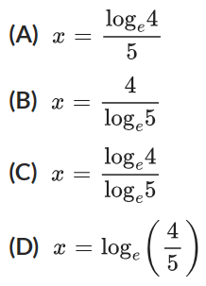
What is the solution of $5^{x}=4$?

$$x=\log_{5}{4}$$
$$=\frac{\log_{e}{4}}{\log_{e}{5}}$$
C
- 2019 HSC Advanced Band 4
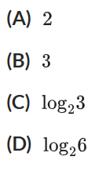
Which of the following is equal to $\frac{\log_{2}{9}}{\log_{2}{3}}?$

$$\log_{3}{9}=2$$
A
- 2019 VCE Band 5
Solve $\log_{3}{(t)}-\log_{3}\left(t^{2}-4\right)=-1$
$$\log_{3}\left(\frac{t}{t^{2}-4}\right)=-1$$
$$\frac{t}{t^{2}-4}=3^{-1}$$
$$\frac{t}{t^{2}-4}=\frac{1}{3}$$
$$3t=t^{2}-4$$
$$t^{2}-3t-4=0$$
$$\left(t-3\right)\left(t+1\right)=0$$
$t=3$ or $-1$
But $t≠-1$ as $\log_{3}{t}$ would be undefined
$$∴t=3$$
- 2020 VCE Band 5
Solve the equation $2\log_{2}{(x+5)}-\log_{2}\left(x+9\right)=1$
$$\log_{2}{{\left(x+5\right)}^{2}}-\log_{2}\left(x+9\right)=1$$
$$\log_{2}\left(\frac{{\left(x+5\right)}^{2}}{x+9}\right)=1$$
$$\frac{{\left(x+5\right)}^{2}}{x+9}=2$$
$${\left(x+5\right)}^{2}=2\left(x+9\right)$$
$$x^{2}+10x+25=2x+18$$
$$x^{2}+8x+7=0$$
$$\left(x+7\right)\left(x+1\right)=0$$
$$x=-7, -1$$
But $x≠-7$ as $\log_{2}\left(x+5\right)$ would be undefined, $∴x=-1$
- Use the given fact to evaluate the given expression.
- $\log_{5}{125}=3$  $\log_{125}{5=}$ ?  $$\frac{1}{3}$$ | - $\log_{100}{10}=\frac{1}{2}$  $\log_{10}{100}=$ ?  2 | - $\log_{4}{\frac{1}{64}}=-3$  $\log_{64}{\frac{1}{4}}=$ ?  $$-\frac{1}{3}$$ | - $\log_{36}{6}=\frac{1}{2}$  $\log_{36}{\frac{1}{6}}=$ ?  $$-\frac{1}{2}$$

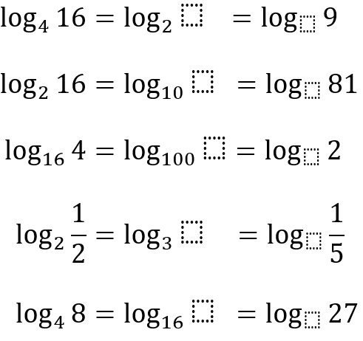
- Fill in the blanks.

4, 3

100, 3

10, 9

$$\frac{1}{3}, 5$$

64, 9

- An advanced technique for solving exponential equations is to take the logarithm of both sides.
This is useful when the bases are different. Answer to 4 s.f.
- Example
Worked example | Your Turn
$$2^{3x}=3^{x+1} \\ \log_{10}{2^{3x}}=\log_{10}{3^{x+1}} \\ 3x\log_{10}{2}=\left(x+1\right)\log_{10}{3} \\ 3x\log_{10}{2}=x\log_{10}{3}+\log_{10}{3} \\ 3x\log_{10}{2}-x\log_{10}{3}=\log_{10}{3} \\ x\left(3\log_{10}{2}-\log_{10}{3}\right)=\log_{10}{3} \\ x=\frac{\log_{10}{3}}{3\log_{10}{2}-\log_{10}{3}} \\ ≈1.120$$ | $$5^{2x}=6^{x+1}$$  $$1.256$$
- Solve $7^{1-x}=6×5^{x-3}$.

$$1.401$$

Exponential Modelling

- Solving Problems involving Exponential Models
When solving exponential equations, use logarithms to find the missing index.
- Write the formula.
- Substitute given values.
- Isolate exponential term.
- Solve using logarithms.

- Example Solve exponential modelling problems using logarithms.
An investment of $10 000 grows by 5% p.a according to the compound interest formula:
$$FV=10000{\left(1.05\right)}^{n}$$
Where $n$ is the number of years. Find the time required for the investment to grow to $32000.
1. Formula $FV=10000{\left(1.05\right)}^{n}$
2. Substitute $32000=10000{\left(1.05\right)}^{n}$
3. Isolate $3.2={1.05}^{n}$
4. Solve $\log_{1.05}{3.2} =n$
$n≈23.84$ years

- Practice
An investment of $20 000 grows by 6% p.a according to the compound interest formula:
$$FV=20000{\left(1.06\right)}^{n}$$
Where $n$ is the number of years. Find the time required for the investment to grow to $50000. Round to 2 decimal places.

15.73 years
A population of mosquitoes is given by $P=8^{t}$ where $t$ is measured in days.
Find the number of days, correct to 2 decimal places, required for the population to reach 200.

2.55 days

Foundation
- The number of plankton in a tank is doubling every 5 days, given by the formula:
$$P=15000×2^{\frac{t}{5}}$$
Where $P$ is population (number of plankton) after $t$ days from commencement of study.
  - What was the initial population when the study commenced?
$$t = 0, P = 15000 × 2^{\frac{0}{5}}= 15000$$
  - What was the population after 15 days?
$$P = 15000 × 2^{\frac{15}{5}}= 15000 × 8 = 120000$$
  - At what time will the population reach 1 920 000?
$$1920000 = 15000 × 2^{\frac{t}{5}}$$
$$128 = 2^{\frac{t}{5}}$$
$$2⁷ = 2^{\frac{t}{5}}$$
$$\frac{t}{5}= 7$$
$$t = 35 days$$
- The temperature in a tank of water is decreasing according to the formula
$$T=100×{\left(0.87\right)}^{h}$$
Where $T$ is temperature in degrees Celsius after $h$ minutes.
  - What was the initial temperature?
100° C
  - How long would it take for the temperature to drop to $70°C$?
$$70 = 100 × {\left(0.87\right)}^{h}$$
$$0.7 = {\left(0.87\right)}^{h}$$
$$h =\log_{0.87}{0.7} = 2.56 minutes$$

- The mass, in grams, of a decaying substance is given by
$$M=18×{\left(1.75\right)}^{-\frac{3t}{5}}$$
Where $t$ is measured in days.
  - What was the initial mass?
18 g
  - What is the half-life? (How long will it take to decay to half its current mass?)
$$9 = 18 × {\left(1.75\right)}^{-\frac{3t}{5}}$$
$$0.5 = {\left(1.75\right)}^{-\frac{3t}{5}}$$
$$-\frac{3t}{5}=\log_{1.75}{0.5}$$
$$t=\frac{5\log_{1.75}{0.5}}{-3}=2.06 days$$

Development
- A bacterial population starts with 1000 bacteria and doubles every half hour.
  - How many bacteria are there after 1 hour?
4000
  - How many bacteria are there after 2 hours?
16000
  - How many bacteria are there after 3 hours?
64000
  - Write down an equation for the population of the bacteria after $t$ hours.
$$1000×2^{2t}$$
  - How long will it take for the population to exceed 10 million? Answer to the nearest minute.
$$1000×2^{2t}>10 000 000$$
$$2^{2t}>10 000$$
$$2t>\log_{2}{10 000}$$
$$t>6.64385…$$
6 hours 39 min

- The value of a bank balance increases by 10% per year. The initial amount is $2000.
  - Write the equation in the form $FV=PV{\left(1+r\right)}^{n}$.
$$FV=2000{\left(1.1\right)}^{n}$$
  - Find the time, correct to two decimals, when the balance is double the original amount.
$$4000=2000{\left(1.1\right)}^{n}$$
$$2={1.1}^{n}$$
$$n=\log_{1.1}{2}$$
$$=7.27 years$$

- The value of a car is expected to reduce by 8% per year. The original cost is $300 000.
  - Write the equation in the form $S=V_{0}{\left(1-r\right)}^{n}$.
$$S=300 000{\left(0.92\right)}^{n}$$
  - Find the time it takes for the car’s value to be half the original value.
Round your answer to 1 decimal place.

$$150000=300 000{\left(0.92\right)}^{n}$$
$$\frac{1}{2}={0.92}^{n}$$
$$n=\log_{0.92}{\frac{1}{2}}$$
$=8.3$years

- A container of hot water is placed in a refrigerator running at $0°C$. The water is known to cool according to Newton’s Law of Cooling; with a given starting temperature of 96$°C$ its temperature halves every 20 minutes. The formula is given by
$$T=96×{\left(\frac{1}{2}\right)}^{3n}, where n is in hours$$
  - What is the temperature after 2 hours?
1.5° C
  - How long does it take, correct to the nearest minute, for the temperature to fall to 1°C?

132 minutes
- The population of a country is doubling every 30 years and was 3 000 000 at the last census.
  - Show, by establishing a pattern, why the population $P$ after $n$ years is$P=3 000 000×2^{\frac{n}{30}}$

$$n = 0: P = 3,000,000 × 2⁰$$
$$n = 30: P = 3,000,000 × 2¹$$
$$n = 60: P = 3,000,000 × 2²$$
$$∴P = 3,000,000 × 2^{\frac{n}{30}}$$
  - Find when the population will be 1 billion, to 1 d.p.

251.4 years
- The half-life of a substance is the time it takes for the substance to reduce to half its original mass. Find the half-life of a radioactive material if its mass reduces by 1% per year.

Let M be original mass.
$$\frac{M}{2} = M × \left(0.99\right)ᵗ$$
$$0.5 = (0.99)ᵗ$$
$$t =\log_{0.99}{0.5}=69.0 years$$

Logarithmic Scales

- Interpret a logarithmic scale.
Total COVID-19 cases in Italy and the US in early 2020:
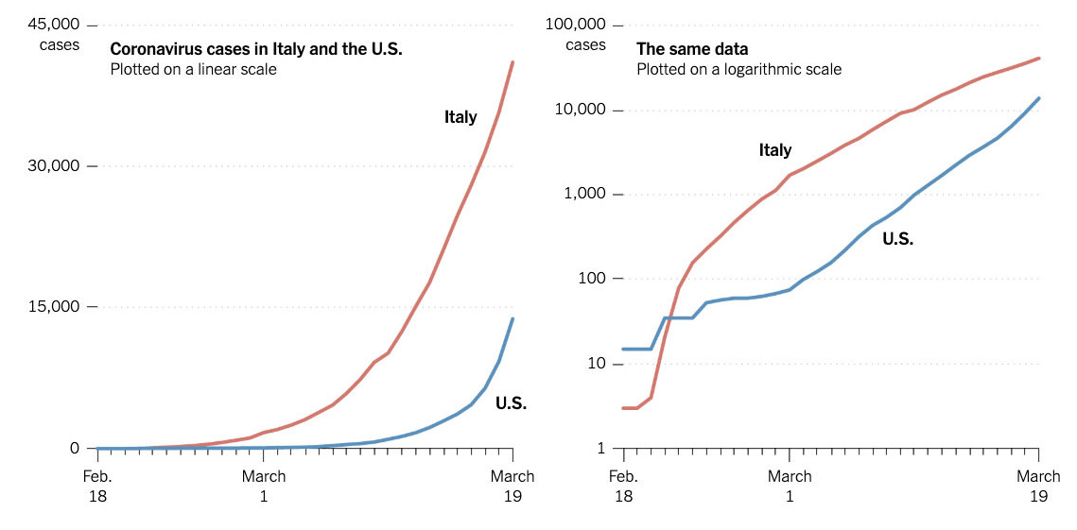

  - What scale is the second graph using? How can you tell?

  - What happens to an exponential relationship when you use a logarithmic scale?
Hint: It’s difficult to tell using real-world data that is constantly changing.
What happens to $y=2^{x}$ when you do $y=\log_{10}\left(2^{x}\right)$?

  - Using the logarithmic scale, what can you say about Italy’s case numbers?
Is it slowing down or accelerating?

  - Using the logarithmic scale, what can you say about USA’s case numbers?
Is it slowing down or accelerating?

  - Why might scientists prefer to use logarithmic scales to track exponential growth scenarios, such as infectious diseases?

- Example Interpret logarithmic scales.
A Richter scale is used to measure Earthquake intensity.
$$M=\log_{10}{A}$$
Where $M$ is the magnitude of the earthquake and $A$ is the amplitude of the ground movements
Rewrite this formula with $A$ as the subject.  $${10}^{M}=A$$ | How many times more powerful is a magnitude 6 earthquake compared to magnitude 3?  Magnitude 6: $A={10}^{6}$  Magnitude 3: $A={10}^{3}$  $$\frac{{10}^{6}}{{10}^{3}}=1000 times as powerful$$

- Practice
pH is used to measure the hydrogen ion concentration in a substance, hence telling us how acidic or basic it is.
$$p=-\log_{10}{H}$$
Where $p$ is the pH of the substance and $H$ is the hydrogen ion concentration.
Rewrite this formula with $H$ as the subject.  $${10}^{-p}=H$$ | Lemonade has a pH of 3 and sparkling water a pH of 5.  How many times more acidic is lemonade compared to sparking water?  $$\frac{{10}^{-3}}{{10}^{-5}}=100 times as acidic$$

Foundation
- Earthquake intensity is measured using the Richter scale
$$M=\log_{10}{A}$$
$M$ is the magnitude of an earthquake.
$A$ is the amplitude of ground movements.
  - Rewrite the formula with $A$ as the subject.

How many times more powerful are these earthquakes compared to each other?
i.e. find the ratio of the amplitudes.
Answer to 2 s.f.
- Magnitude 2 (smallest humans can feel)  Magnitude 6 (major damage)  $$\frac{{10}^{6}}{{10}^{2}}=10 000 times as powerful$$ | - 3.5 and 6?  $$\frac{{10}^{6}}{{10}^{3.5}}=320 times as powerful$$
- 3.2 and 8.6?  $$250000 times as powerful$$ | - 2.8 and 3.6?  $$6.3 times as powerful$$

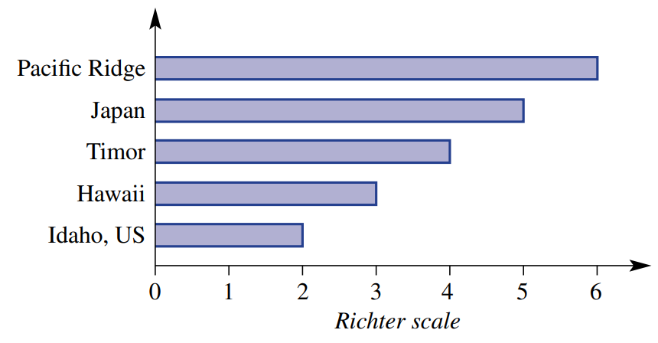
- This chart shows the Richter scale measurements rounded to the nearest integer for five different earthquakes recorded in 2022.

  - What is the difference between the magnitude of the earthquakes for Pacific Ridge compared to Timor?
2
  - Therefore, explain why the earthquake in Pacific ridge was 100 times more powerful compared to Timor.
$${10}^{2}=100$$
  - What is the difference between the magnitude of the earthquakes for Japan compared to Idaho?
3
  - Therefore, how many times more powerful was the earthquake in Japan compared Idaho?
1000

Development
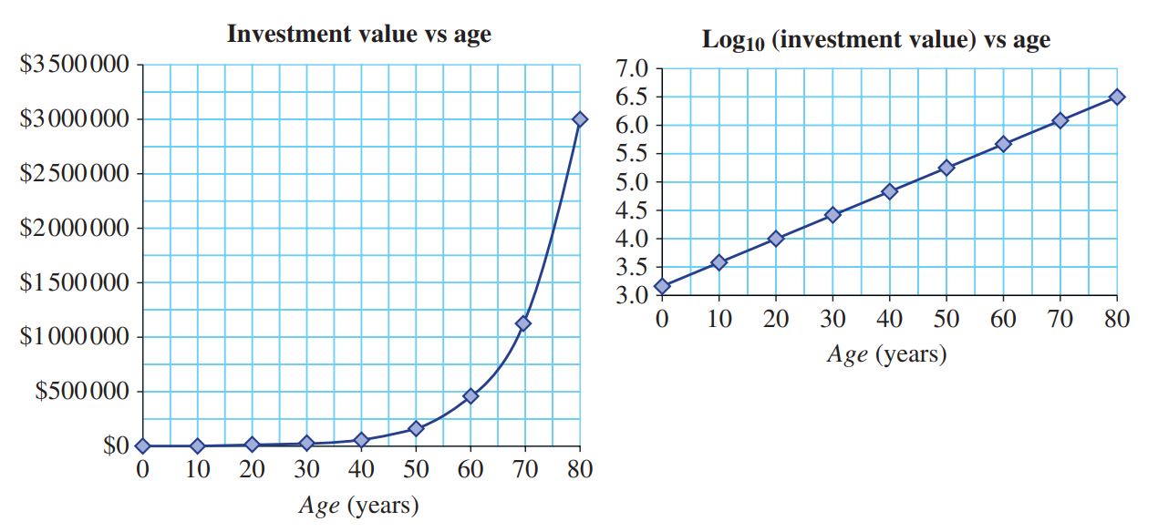
- The two graphs shows $1500 earning compound interest over 80 years.

  - What investment value does 3.6 correspond to on the log scale?
$${10}^{3.6}=\$3981$$
  - Which graph can be used to find the investment value at age 20 years and what is this value?
The log graph. ${10}^{4}=10000$
  - By what factor has the investment value increased from age 20 to age 30?
Looking at the log graph, the difference between 30 and 40 is around 0.4
$${10}^{0.4}≈2.5$$
2.5 times
  - By what factor has the investment value increased when the log scale increases by 1 unit?
10 times
  - If a graph using a log scale is linear, what form is the graph of the original data?
Exponential
- The following table includes data about the value of an investment $A over $t$ years.
  - Calculate the value of $\log_{10}{A}$ for each of the values of $A$ on the table.
$$t$$ | 0 | 1 | 2 | 3 | 4 | 5
$$A$$ | 10 000 | 12 000 | 14 400 | 17 280 | 20 736 | 24 883.2
$$\log_{10}{A}$$
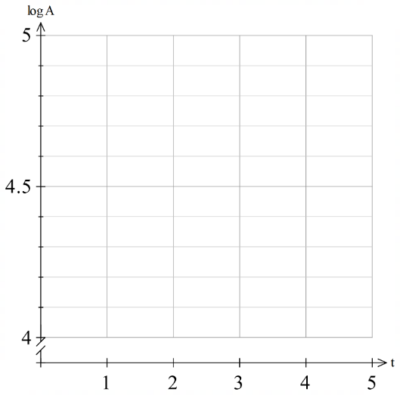
  - Plot $\left(t,\log_{10}{A}\right)$ on this graph.

  - What does this say about the type of relationship
between $t$ and and $A$?

Since the log graph is linear, the original must be exponential.

- The pH of a liquid is traditionally defined on a logarithmic scale as $pH=-\log_{10}{(x)}$, where $x$ is the hydrogen ion concentration in moles per litre (mol/L). The greater the concentration of hydrogen ions, the more acidic it is.
  - Rewrite the formula with $x$ as the subject.
$$x = 10⁻ᵖᴴ$$
  - Pure water has a pH of about 7. What is its hydrogen ion concentration?
10⁻⁷ mol/L
  - Lemon juice typically has a pH of about 2.0. What is its hydrogen ion concentration?
How many times more acidic is it than pure water?

  - mol/L
$\frac{0.01}{1 × {10}^{-7}}$ = 100,000 times more acidic than pure water
  - Sea water typically has a pH of about 8. What is its hydrogen ion concentration?
How many times more alkaline (meaning ‘less acidic’) is it than pure water?
10⁻⁸ mol/L
10 times less acidic (more alkaline) than pure water
- The human ear is very sensitive. Sound intensity is measured using decibels (dB).
$$S=10\log_{10}{\frac{I}{I_{0}}}$$
Where $S$ is the sound intensity in decibels,
$\frac{I}{I_{0}}$ is how many times louder a sound is compared to the threshold of human hearing.
How many times louder than the threshold for human hearing is the sound of the following?
(i.e., Find $\frac{I}{I_{0}})$
- Normal conversation  60 dB  $$60=10\log_{10}{\frac{I}{I_{0}}}$$  $$6=\log_{10}{\frac{I}{I_{0}}}$$  $$\frac{I}{I^{0}}= {10}^{6}= 1,000,000$$ | - Whispering  20 dB  100 | - How many times louder is 60 dB vs 20 dB?  10 000 times louder

- Using a log base 10 scale, the magnitude of the volume of water in Lake Victoria is 8 and the magnitude of the volume of water in Lake Anne is 5.
There is 500 000 ML of water in Lake Anne.

That means Lake Victoria has 800 000 ML of water.

Explain why this is incorrect and state the correct volume of Lake Victoria.
Using a base 10 scale, a difference of 3 means a difference of ${10}^{3}$ in the original scale.
Lake Victoria has 500 000 000 ML of water.

The Logarithmic Curve

- Investigation Graph logarithmic curves using a table of values.
Sketch the graphs of $y=2^{x}$ and $y=\log_{2}{x}$ on the same axis.
$y=2^{x}$
$$x$$ | $$-3$$ | $$-2$$ | $$-1$$ | $$0$$ | $$1$$ | $$2$$ | $$3$$
$$y$$

$y=\log_{2}{x}$
$$x$$ | $$-1$$ | $$0$$ | $$\frac{1}{4}$$ | $$\frac{1}{2}$$ | $$1$$ | $$2$$ | $$4$$ | $$8$$ | $$16$$
$$y$$

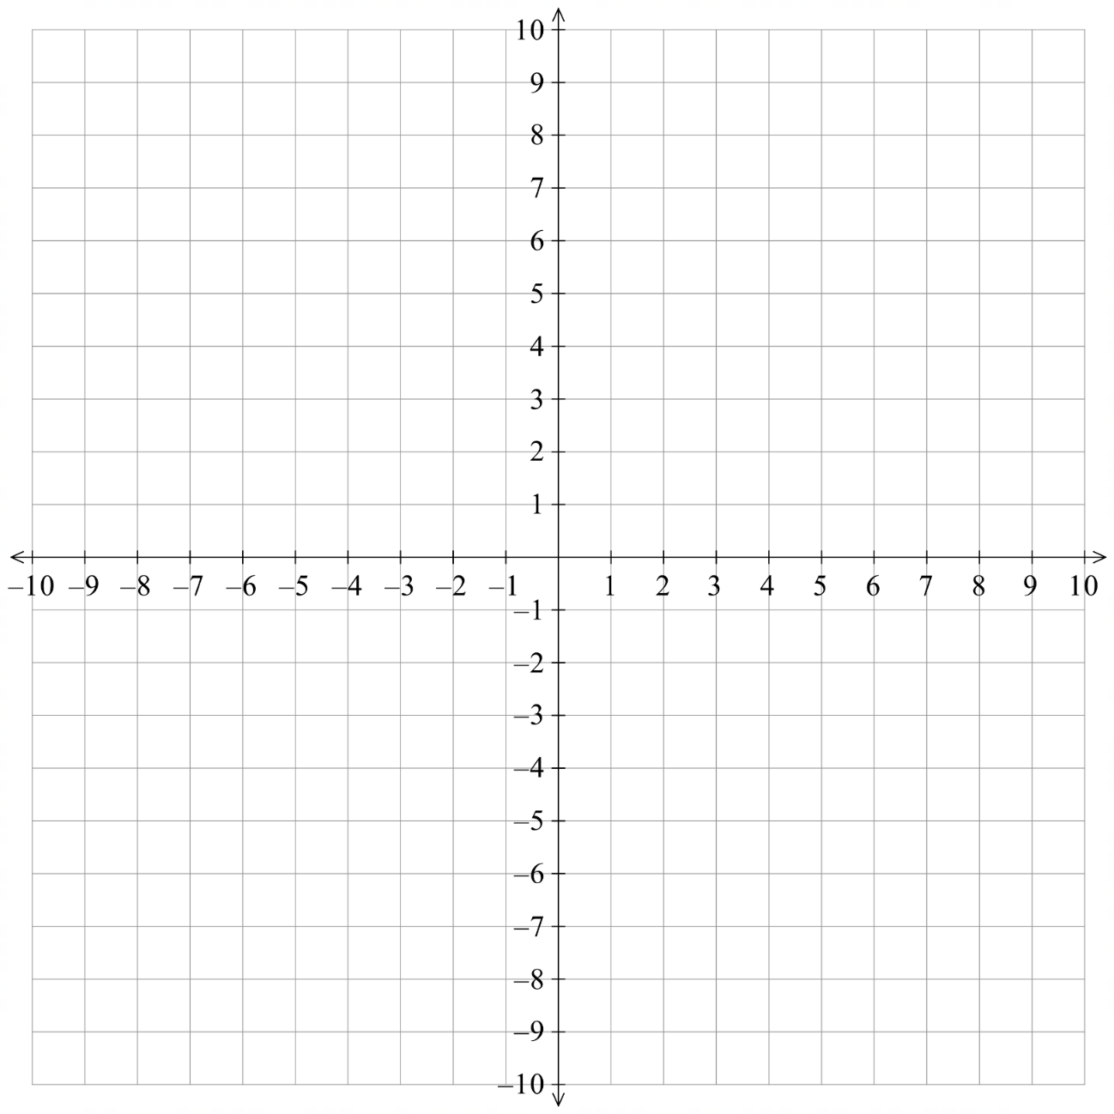

Why can’t the inside of a logarithm be zero or negative?
The definition of a logarithm says that the inside of a logarithm must be ……………………
Consider $x=\log_{2}{-1}$, changing to index form: ……… = …………, which is impossible.
What do you notice about the graphs of $y=2^{x}$ and $y=\log_{2}{x}?$
They are …………………… of each other across the line …………

Where are the asymptotes for $y=2^{x}$ and $y=\log_{2}{x}?$ ………………………………………
- Investigation Logarithmic Curve Transformations.
- Using Desmos:

- Sketch
$y=a^{x}$
$y=\log_{a}{x}$

Use the slider to change the value of $a$.
Are the graphs always reflections of each other across $y=x$?

- Sketch
$y=\log_{2}{x}$  $y=\log_{3}{x}$  $y=\log_{1.1}{x}$  $y=\log_{0.9}{x}$  $y=\log_{\frac{1}{2}}{x}$ | When $a>1$, the graph always has a …………………… gradient; it is always i………………  When $0<a<1,$the graph always has a …………………… gradient, it is always d………………

- Logarithmic Curve Transformations
For a logarithmic curve $y=log_{a}\left(x\right):$
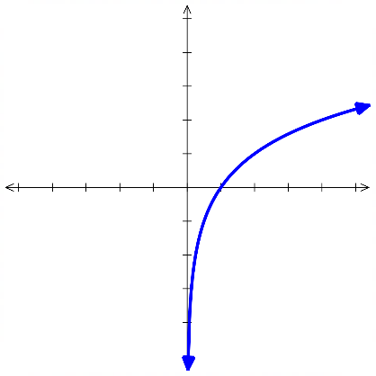  $a>0$, the curve is increasing.  $$y=\log_{2}{x }$$ | $0<a<1$, the curve is decreasing  $$y=\log_{0.5}{x}$$  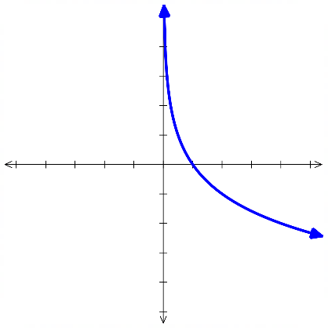
$y=log_{a}x$ and $y=a^{x}$ are reflections of each other across the mirror line $y=x$
$y=\log_{3}{x}$ $y=\log_{\frac{1}{3}}{x}$
$y=3^{x}$ $y={\left(\frac{1}{3}\right)}^{x}$
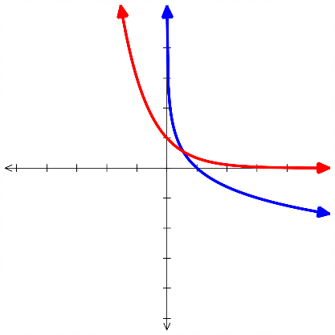
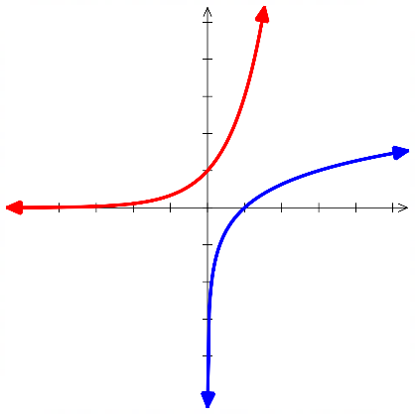

- Natural Domain of a Logarithmic Function
For a logarithm,
$$y=\log_{a}\left(f\left(x\right)\right)$$
The natural domain is $f\left(x\right)>0.$

- Identify Domain of a logarithmic function
$$\log_{3}\left(x-4\right)$$  $$x-4>0 \\ x>4$$ | $$\log_{10}\left(x+4\right)$$  $$x+4>0 \\ x>-4$$ |  | $$\log_{10}\left(x+4\right)$$  $$x+4>0 \\ x>-4$$ |  | $$\log_{10}\left(2x+4\right)$$  $$2x+4>0 \\ x>-2$$
Identify the domain of these logarithmic functions.
- $\log_{2}(x-7)$ |  | - $\log_{2}(x+7)$ |  | - $\log_{2}(3x+7)$
- $\log_{2}(7-3x)$ |  | - $\log_{5}x+7$ |  | - $\log_{4}\left(2x-5\right)-11$

Foundation
- For the function $y=\log_{4}{x},$
  - complete the table:
$$x$$ | $$\frac{1}{16}$$ | $$\frac{1}{4}$$ | $$4$$ | $$16$$
$$y$$

  - hence state whether $y=\log_{4}{x}$ is an increasing or decreasing.
increasing

- For the function $y=\log_{\frac{1}{2}}{x},$
  - complete the table:
$$x$$ | $$\frac{1}{2}$$ | $$1$$ | $$2$$ | $$4$$
$$y$$

  - hence state whether $y=\log_{\frac{1}{2}}{x}$ is an increasing or decreasing.
decreasing

- State whether these functions are increasing or decreasing.
- $y=\log_{3}{x}$  increasing | - $y=\log_{3}\left(x-4\right)$  increasing | - $y=\log_{3}\left(5x\right)$  increasing
- $y=\log_{\frac{1}{3}}{x}$  decreasing | - $y=\log_{0.3}\left(x-4\right)$  decreasing | - $y=\log_{25}\left(5x\right)$  increasing
- $y=\log_{1.01}{x}$  increasing | - $y=\log_{0.99}{x}$  decreasing | - $y=\log_{3}\left(-x\right)$  decreasing

Development
- State the natural domain of these functions.
- $y=\log_{2}\left(x-3\right)$  $$x>3$$ | - $y=\log_{2}{x}-3$  $$x>0$$ | - $y=\log_{2}\left(x+4\right)$  $$x>-4$$
- $y=\log_{2}{x}+4$  $$x>0$$ | - $y=\log_{2}\left(x-4\right)+3$  $$x>4$$ | - $y=\log_{5}\left(x-2\right)+1$  $$x>2$$
- $y=\log_{10}\left(4x+1\right)$  $$x>-\frac{1}{4}$$ | - $y=\log_{2}\left(-x\right)$  $$x<0$$ | - $y=\log_{2}\left(5-2x\right)$  $$x<\frac{5}{2}$$

- Sketch each set of graphs on Desmos and answer the questions.
$$y=\log_{2}\left(x+1\right)$$ | $$y=\log_{2}\left(x+7\right)$$ | $$y=\log_{2}\left(x-3\right)$$
  - How does the value of $b$ in $\log_{a}\left(x-b\right)$ affect the graph?
Horizontal translation
$$y=\log_{2}\left(x\right)+1$$ | $$y=\log_{2}\left(x\right)+7$$ | $$y=\log_{2}\left(x\right)-3$$
  - How does the value of $c$ in $\log_{a}\left(x\right)+c$ affect the graph?
Vertical translation

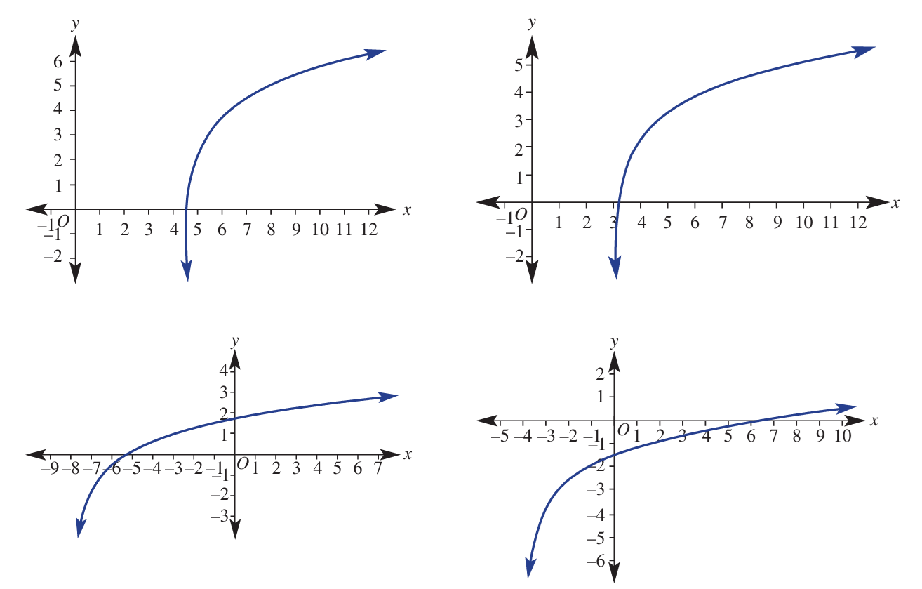
- For the graph of $y=\log_{2}\left(x-4\right)+3$:
  - State the domain.
$$x>4$$
  - State the equation of the asymptote.
$$x=4$$
  - Determine the $x$-intercept by letting $y=0$.

$$(4.125, 0)$$
  - State the horizontal and vertical translations applied to the graph of $\log_{2}{x}.$

Right by 4, up by 3
- For the graph of $y=\log_{2}\left(x-3\right)+2$:
  - State the domain.
$$x>3$$
  - State the equation of the asymptote.
$$x=3$$
  - Determine the $x$-intercept by letting $y=0$.

$$(3.25, 0)$$
  - State the horizontal and vertical translations applied to the graph of $\log_{2}{x}.$

Right by 3, up by 2
- For the graph of $y=\log_{2}\left(x+4\right)-3.5$:
  - State the domain.
$$x>-4$$
  - State the equation of the asymptote.
$$x=-4$$
  - Determine the axis intercepts.

$$(7.31, 0)$$
$$(0, -1.5)$$
  - State the horizontal and vertical translations applied to the graph of $\log_{2}{x}.$

left by 4, down by 3.5

- Consider the curve $y=\log_{a}{x}$ below.
Which is a possible value of $a:$ $\frac{2}{3}$ or $\frac{3}{2}$ ? Explain your answer.
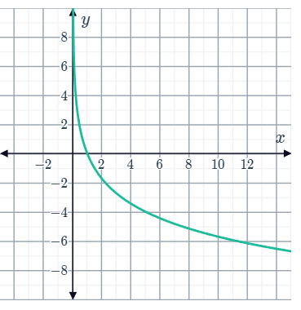

$$a=\frac{2}{3}$$
The base must be less than one as the graph is decreasing.

Mastery
- Find the equation of the following functions, given it is of the stated form:
- $y=\log_{k}{x}$  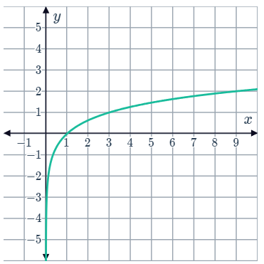  Using (3,1)  $$1=\log_{k}{3}$$  Exponentiate both sides base $k$  $$k^{1}=3$$  $$∴k=3$$ | - $y=k\log_{2}{x}$  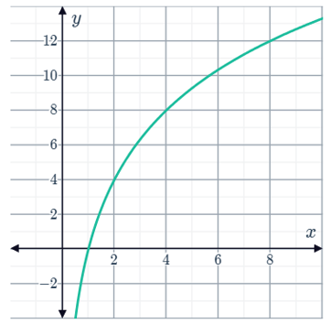  $$y=4\log_{2}{x}$$
- $y=\log_{4}\left(x\right)+c$  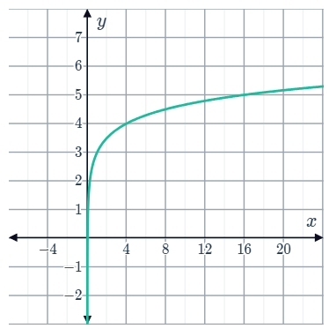  $$y=\log_{4}{x}+3$$ | - $y=k\log_{2}\left(x\right)+c$  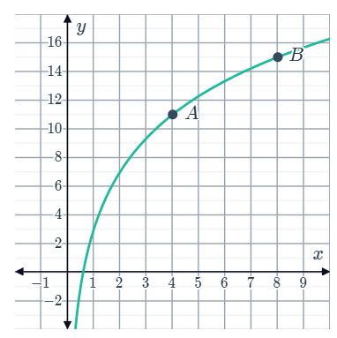  $$y=4\log_{2}{x}+3$$

- Determine the equation for each logarithmic graph in the form $y=\log_{a}\left(x-b\right)+c$.
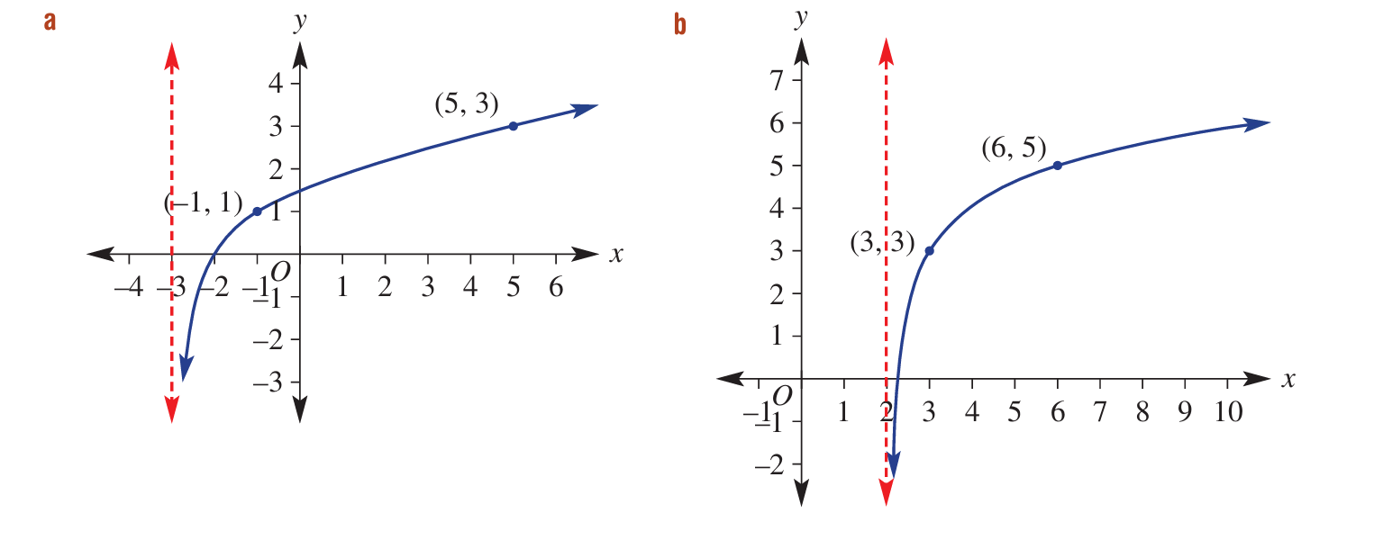

$$y=\log_{2}\left(x+3\right)$$

$$y=\log_{2}\left(x-2\right)+3$$
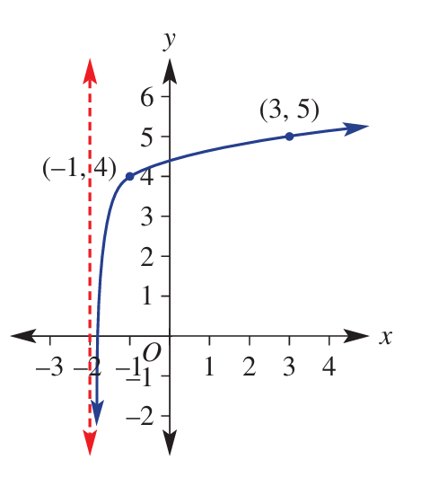

$$y=\log_{5}{(x+2)}+4$$

$$y=\log_{3}\left(x+3\right)-1$$

Logarithmic Inequalities

- Review
- Write exponentials in logarithmic form
- $3^{x}=11$ | - ${(1.2)}^{x}=2$

- Solve linear inequalities
- $2x-5>0$ | - $-4x+6<11$

- Identify domain of a logarithm
- $\log_{3}\left(x-5\right)$ | - $\log_{11}\left(x+4\right)$

- Reversing the Inequality Sign
Multiplying or dividing both sides of an inequality by a negative flips the inequality sign:
$$5>3$$
$$×-2 ×-2$$
$$-10<-6$$

But what happens when we take the logarithm of both sides?
Test it out by evaluating both sides.
$$5>3$$
$$\log_{5}{} \log_{5}{}$$
$\log_{5}{5}$ …… $\log_{5}{3}$

$$5>3$$
$$\log_{0.5}{} \log_{0.5}{}$$
$\log_{0.5}{5}$ …… $\log_{0.5}{3}$

When you take the logarithm of a base …………… than one, you flip the inequality sign.
The reason for this is that $f\left(x\right)=\log_{0.5}{x}$ is a decreasing function.
The rule is: Applying a strictly decreasing function to both sides of an inequality reverses the direction of the inequality sign.
A strictly decreasing function maps larger inputs to smaller outputs.

This is true of the simple example at the start as well. Instead of thinking of this as multiplying by $-2$, instead think of it as applying the decreasing function $f\left(x\right)=-2x$ to both sides.

$$5>3$$
$$f\left(5\right) f\left(3\right)$$
$$-10<-6$$

- Logarithms and Inequalities
When applying a logarithm to both sides $f\left(x\right)=\log_{a}{x}$,
Keep the inequality sign the same if $a>1.$
Reverse the inequality sign if $0<a<1$.

- Example Solve logarithmic inequalities
$$2^{x}>3$$  $$\log_{2}{} \log_{2}{}$$  $$x>\log_{2}{3}$$ | $${0.5}^{x}>3$$  $$\log_{0.5}{} \log_{0.5}{}$$  $$x<\log_{0.5}{3}$$

- Guided Practice
Solve the following for $x$.
- $2^{x}>9$ | - $5^{x}<8$
- ${\left(0.2\right)}^{x}>11$ | - ${\left(\frac{2}{3}\right)}^{x}-10<4$

Foundation
- Solve, giving your answer to 3 d.p.
- $2^{x}>5$  $$x>2.322$$ | - $3^{x}>7$  $$x>1.771$$ | - $5^{x}<8$  $$x<1.292$$
- ${10}^{x}<6$  $$x<0.778$$ | - $4^{x}≥9$  $$x≥1.585$$ | - $7^{x}≤20$  $$x≤1.540$$
- ${0.5}^{x}>4$  $$x<-2$$ | - ${0.5}^{x}<3$  $$x>-1.585$$ | - ${0.25}^{x}>6$  $$x<-1.292$$
- $6^{x}>11$  $$x>1.388$$ | - ${0.4}^{x}>11$  $$x<-2.617$$ | - ${0.7}^{x}<12$  $$x>-6.967$$
- ${1.05}^{x}>2$  $$x>14.207$$ | - ${0.95}^{x}>2$  $$x<-13.513$$ | - ${1.2}^{x}≤4$  $$x≤7.604$$

- Solve:
- $3\left(2^{x}\right)>21$  $$x>2.807$$ | - $4\left(5^{x}\right)<36$  $$x<1.365$$ | - $2{\left(0.5\right)}^{x}>6$  $$x<-1.585$$
- $5{\left(0.8\right)}^{x}<15$  $$x>-4.923$$ | - $7{\left(1.1\right)}^{x}+2>30$  $$x>14.545$$ | - $100{\left(0.9\right)}^{x}<40$  $$x>8.697$$

Development
- $1000 is invested at $5\%$ compound interest per year.
After how many whole years will the balance first exceed $2500?

19 years
- $2000 is invested at $8\%$ per year. After how many whole years will it exceed $20 000?

30 years
- A car worth $20 000 loses 10% of its value per year.
After how many whole years will its value first fall below $8000?

9 years
- A machine worth $400 000 loses 15% of its value per year.
After how many whole years will its value first fall below $20 000?

13 years
- A medicine in the bloodstream loses 20% of its concentration every hour.
If 100 mg is injected at the start, after how long will less than 30 mg remain?
Answer to the nearest minute.

5 hours 24 minutes
- A disease doubles the number of infected individuals every week.
If 50 people were infected at the start, after how long will 8 billion people be infected?
Give your answer in whole weeks and the nearest day.

27 weeks 2 days
- The temperature difference between a cup of coffee and its surroundings decreases by 25% every 5 minutes. The coffee is initially 60 degrees hotter than its surroundings; this can be modelled by $D=60{\left(0.75\right)}^{t}$ where $t$ is the number of 5 minute periods. After how long will it take for the temperature difference to be less than 5°C? Answer to the nearest whole minute.

44 min

The Natural Logarithm

- Natural Logarithm
Logarithms of base $e$ are called natural logarithms.
$$\log_{e}{x}=\ln{x}$$
$e^{x}$ and $\log_{e}{x}$ are inverses of each other.
Engineers and some calculators use $\log{x}$ to mean log₁₀ $x$.
However, many mathematicians use $\log{x}$ to mean $\log_{e}{x}$.
Follow these two rules to avoid confusion:
- Always write the base: use log₁₀ $x$ or $\log_{e}{x}$, never just "$\log{x}$"
- For the natural logarithm, always write either $\ln{x}$ or $\log_{e}{x}$

- Evaluating Natural Logarithms
All log laws apply.
$$\ln{1}=0$$ | $${\ln{e}}^{x}=x$$
$$\ln{e}=1$$ | $$e^{\ln{x}}=x$$

- Evaluate expressions involving natural logarithms using the log laws.
- $\ln{e^{10}}$ | - $e^{\ln{10}}$ | - $\ln{5}+\ln{3}$
- $\ln{\sqrt{e}}$ | - $\ln{e^{3}}$ | - $\ln{e^{1.3}}$
- $e^{\ln\left(\frac{1}{5}\right)}$ | - $\ln{12}-\ln{4}$ | - $\ln{\sqrt[3]{e}}$


Foundation
- Use the button on your calculator to evaluate the following expressions.
- $\ln{1}$  0 | - $\ln{3}$  1.099 | - $\ln{\frac{1}{8}}$  -2.079 | - $\ln{e^{2}}$  2

- Evaluate these logarithms without a calculator.
- $\ln{e^{3}}$  3 | - $\ln{e^{-2}}$  –2 | - $e^{\ln{2}}$  2 | - $e^{\ln{10}}$  10
- $\ln{e^{\frac{1}{5}}}$  $$\frac{1}{5}$$ | - $e^{\ln{\frac{1}{2}}}$  $$\frac{1}{2}$$ | - $e^{\ln{(4^{2})}}$  16 | - $e^{\ln{\frac{1}{5}}}$  $$\frac{1}{5}$$

- Evaluate these expressions using the log law $\ln{a^{n}}=n\ln{a}$ and the fact that $\ln{e}=1$
- $e\ln{e}$  $$e$$ | - $\frac{1}{e}\ln{\frac{1}{e}}$  $$-\frac{1}{e}$$ | - $3\ln{e^{2}}$  6
- $\ln{e^{5}}$  5 | - $\ln{e^{200}}$  200 | - $\ln{e^{-6}}$  –6
- $\ln{\frac{1}{e^{6}}}$  –6 | - $\ln{e^{-1}}$  –1 | - $\ln{e^{\frac{1}{2}}}$  $$\frac{1}{2}$$
- $\ln{\sqrt{e}}$  $$\frac{1}{2}$$ | - $\ln{\frac{1}{\sqrt{e}}}$  $$-\frac{1}{2}$$ | - $\ln{\frac{1}{\sqrt{e^{3}}}}$  $$-\frac{1}{3}$$
- $e\ln{e^{3}}-e\ln{e}$  $$2e$$ | - $\ln{e}+\ln{\frac{1}{e}}$  $$0$$ | - $e\ln{e^{3}}-e\ln{e}$  $$2e$$

Development
- An object is dropped from an aeroplane. Let $s$ be the speed of the particle in metres per second, and $t$ be time in seconds. The speed of the particle is given by the formula $s = 10\left(1 - e^{-t}\right).$
  - Find the speed of the particle two seconds after release.

8.65 m/s
  - How long does it take for the particle to reach a speed of 5 metres per second?

$t=\ln{2}=$ 0.69 seconds
  - Does this particle ever reach a speed of 10 metres per second? Justify your answer.

No, it approaches but never reaches 10.
- When antibiotics are introduced into the human body, the concentration the antibiotic in the bloodstream can be modelled by the equation
$$C(t) = 9\left(e^{-0.2t}- e^{-0.4t}\right)$$
where $t$ is time in hours and $C$ is measured in $μg {mL}^{-1}$.
  - What is the concentration of the antibiotic after 1 hour?

1.34 $μgmL^{-1}$
  - Let $x = e^{-0.2t}$ and show that when $C = 2$, the resultant quadratic is $9x² - 9x + 2 = 0$.
$$Let x = e^{-0.2t}, then 9\left(e^{-0.2t}-e^{-0.4t}\right)=9\left(x-x^{2}\right)$$
$$When C = 2:$$
$$2 = 9(x - x²)$$
$$2 = 9x - 9x²$$
$$9x² - 9x + 2 = 0$$
  - Solve for $x$, and hence show that it will take just over 2 hours to reach $2μg {mL}^{-1}$.
$$\left(3x-1\right)\left(3x-2\right)=0$$
$$∴ e^{-0.2t}=\frac{1}{3},\frac{2}{3}$$
$$t₁ = -ln(2/3)/0.2 = 2.03 hours$$
$$t₂ = -ln(1/3)/0.2 = 5.49 hours$$
  - You should have acquired two solutions. What could be a biological reason as to why there may be two times when the concentration is $2μg mL^{-1}$?

The concentration rises initially as the antibiotic is absorbed, reaches a peak, and then falls as it is metabolised.
This concentration occurs twice: once while rising and the other while falling
- Solve:
- $6x^{2}+7x-5=0$  $$x =\frac{1}{2}or x = -\frac{5}{3}$$ | - $6\sin^{2}{x}+7\sin{x}-5=0$ for $x∈\left[0,2π\right]$  $$Let u = sin x:$$  $$u =\frac{1}{2}or u = -\frac{5}{3}$$  $$Since -1 ≤ sin x ≤ 1, only sin x =\frac{1}{2}is valid$$  $$x =\frac{π}{6}or x =\frac{5π}{6}$$
- $6{\left(\log_{3}{x}\right)}^{2}+7\log_{3}{x}-5=0$  $$Let y =\log_{3}{x}: 6y^{2}+ 7y - 5 = 0$$  $$y =\frac{1}{2}or y = -\frac{5}{3}$$  $$\log_{3}{x}=\frac{1}{2}$$  $$x = 3^{\frac{1}{2}}= \sqrt{3}$$  $$\log_{3}{x}=-\frac{5}{3}$$  $$x = 3^{-\frac{5}{3}}=\frac{1}{\sqrt{3^{5}}}=\frac{1}{9\sqrt{3}}$$ | - $6e^{2x}+7e^{x}-5=0$  $$Let z = e^{x}: 6z^{2}+ 7z - 5 = 0$$  $$z =\frac{1}{2}or z = -\frac{5}{3}$$  $$Since e^{x}> 0, only e^{x}=\frac{1}{2}is valid$$  $$x = ln\left(\frac{1}{2}\right)= -ln 2$$

Exponential Rate of Change Problems involving Logarithms

- Example Solve exponential rate of change problems involving logarithms
The number $B$ of bacteria in a laboratory culture is growing according to $B=4000e^{0.1t}$,
where $t$ is the time in hours after the experiment was started.
Answer these questions correct to three significant figures:
- How many bacteria are there initially?  $$B\left(0\right)=4000e^{0}=4000$$ | - How many bacteria are there after 5 hours?  $$B\left(5\right)=4000e^{0.1\left(5\right)}≈6590$$
- Find the rate at which the number of bacteria is changing.  $$\frac{dB}{dt}=400e^{0.1t}$$ | - At what rate are the bacteria increasing after 5 hours?  Let $t=5$  $$\frac{dB}{dt}=400e^{0.5}=518 bacteria/h$$
- When are there 10 000 bacteria?  $B\left(t\right)=10000$  $$4000e^{0.1t}=10000$$  $e^{0.1t}=2.5$  $0.1t=\ln{2.5}$  $$t=\frac{\ln{2.5}}{0.1}=9.16 hours$$ | - When are the bacteria increasing by  10 000 per hour?  $$\frac{dB}{dt}=10000$$  $$400e^{0.1t}=10000$$  $$e^{0.1t}=25$$  $$0.1t=\ln{25}$$  $$t=\frac{\ln{25}}{0.1}=32.2 hours$$

- Practice
The temperature of a metal in $°C$ as it cools down over $t$ minutes is $T=27+219e^{-0.032t}$
Answer these questions correct to three significant figures:
- What is the temperature initially?  246° C | - What temperature will the rod cool to eventually?  27°C
- Find the rate at which the temperature is changing.  $$-7.01e^{-0.032t} °C/min$$ | - At what rate is the temperature changing after 20 minutes?  –3.68 °C/min
- When is the temperature 200°C?  7.37 min | - When is the metal cooling at 5°/min?  10.6 minutes

Foundation
- A population P of insects over time $t$ weeks is given by$P = 3e^{1.4t}+ 12 569$.
  - What is the initial population?

$$At t = 0: P = 3e^{0}+ 12 569 = 3 + 12 569 = 12 572$$
  - Find the rate of change, to the nearest whole number, of the number of insects after:
    - 3 weeks
    - 7 weeks

$$\frac{dP}{dt}= 3\left(1.4\right)e^{1.4t}= 4.2e^{1.4t}$$
$$i At t = 3:\frac{dP}{dt}= 4.2e^{4.2}≈ 280 insects/week$$
$$ii At t = 7:\frac{dP}{dt}= 4.2e^{9.8}≈ 75742 insects/week$$
- The displacement of a particle over time $t$ seconds is given by $x = 2e^{4t}$ metres.
  - What is the initial displacement?

At t = 0: $x = 2e^{0}$ = 2 m
  - What is the exact velocity after 10 s?
$$\frac{dx}{dt}= 8e^{4t}$$
$$at t = 10: v = 8e^{40} m/s$$
  - Find the acceleration after 2 s correct to 1 decimal place.
$$\frac{dv}{dt}= 32e^{4t}$$
$$at t = 2: a = 32e^{8}≈ 95 390.7 m/s²$$

- The displacement of an object in cm over time $t$ seconds is given by $x = 6e^{-0.34t}- 5$ . Find:
  - the initial displacement

$$At t = 0: x = 6e^{0}-5 = 1 cm$$
  - the initial velocity
$$\frac{dx}{dt}= 6\left(-0.34\right)e^{-0.34t}= -2.04e^{-0.34t}$$
$$at t = 0: v = -2.04 cm/s$$
  - the displacement after 4 s

–3.46 m
  - the velocity after 9 s

–0.096 cm/s
  - the acceleration after 2 s
$$\frac{dv}{dt}=0.694e^{-0.34t}$$
At $x=2, a=0.35$ cm/s²

Development
- A population $P$ is varying with time $t$ in hours according to the formula $P = 2000 e^{0.3t}.$
  - Find the population when $t = 5$.
$$P\left(5\right)=8963$$
  - Find, as a function of $t$, the rate $\frac{dP}{dt}$ the population is changing, and show $\frac{dP}{dt}= 0.3P.$
$$\frac{dP}{dt}=600e^{0.3t}=0.3×2000e^{P}=0.3P$$
  - Find the rate at which the population is changing when $t = 5$.
$P^{'}\left(t\right)=2689$ individuals/hr
  - Find the average rate of change over the first 5 hours.
$$\frac{P\left(5\right)-P\left(0\right)}{5-0}=1393 individuals/hr$$

- The concentration $C = 2000 e^{-2t}$ of a chemical is varying with time $t$ in years.
  - Find the concentration when $t = 2$.
36.63
  - Find, as a function of $t$, the rate $\frac{dC}{dt}$ at which the concentration is changing.
$$\frac{dC}{dt}=-4000e^{-2t}$$
  - Find the rate at which the concentration is changing when $t = 2$.
$$-73.26/yr$$

- The price $$P$ of an item is rising with inflation according to the formula $P = 150 e^{0.04t}$, where $t$ is the time in years.
  - When will the price be $300?
$$t=25\ln{2}≈17.33 yrs$$
  - Find the rate $\frac{dP}{dt}$ at which the price is rising.

$$\frac{dP}{dt}=6e^{0.04t}$$
  - When will the price be rising at $300 per year?

$$t=25\ln{50}≈97.80 yrs$$

- The population $P$ of cats on Snake Island is $P = 1000 e^{0.4t}$, where $t$ is the time in years after time zero when the population was first estimated.
  - Find the rate at which the population is increasing.
$$\frac{dP}{dt}=400e^{0.4t}$$
  - Find the population, and the rate of increase, when $t = 5$, both correct to 2 s.f.

$$P\left(5\right)≈7400 cats, P^{'}\left(5\right)≈3000 cats/yr$$
  - When will the cat population reach 20 000 cats, correct to one decimal place?

$$t=\frac{5}{2}\ln{20}≈7.5 yrs$$
  - When will the rate of increase reach 20 000 cats per year, correct to one decimal place?

$$t=\frac{5}{2}\ln{50}≈9.8 yrs$$

- A radioactive substance decays in such a way that the mass $M$ of a sample $t$ years after it has been measured and stored is $M = M_{0}e^{-0.1t}$, where M₀ is its original mass.
  - How long until half the sample is gone?
Let $M=$ $\frac{M_{0}}{2}$
$$\frac{1}{2}=e^{-0.1t}$$
$$\ln{\frac{1}{2}}=-0.1t$$
$$t=-10\ln{\frac{1}{2}}≈6.931 yrs$$
  - Find the rate $\frac{dM}{dt}$ at which the sample is decaying, and show that $\frac{dM}{dt}$ $= -0.1 × M$.

$$\frac{dM}{dt}=-0.1×M_{0}e^{-0.1t}=-0.1M$$
  - What percentage of the remaining sample decays each year?

Every year you multiply by $e^{-0.1}$
This is a multiplier of $×0.9048…$
$∴9.516\%$ decrease
  - When will the rate of decay be 1% of the original mass M₀ per year?
$$Let \frac{dM}{dt}=-0.01M_{0}$$
$$t=-10\ln{10}≈23.03 yrs$$

